**Exploring Weather Trends**

# Tools used:

1- to extracting Temperature data for global and my city; I used SQL query as shown in figures, and I downloaded data as CSV:

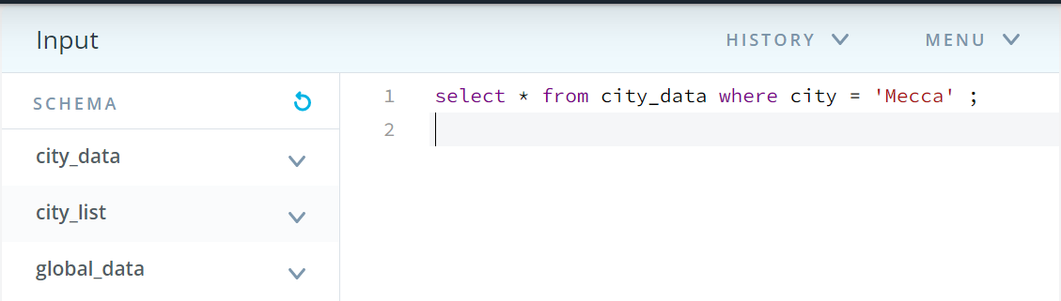

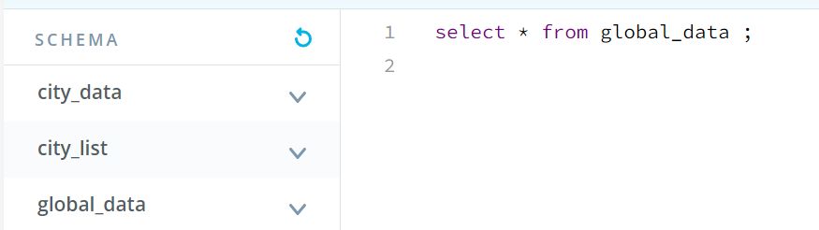

2-To join global average temperature data and Mecca data for each year, I used VLOOKUP() function as in figure:

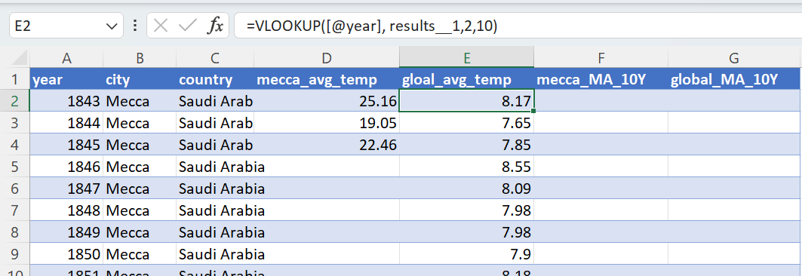

Figure 1. VLOOKUP() function used to join Global and Mecca Temperature data

3- There are around 14 rows in Mecca Temperature are missing, so I fill the missing values by the mean of Mecca Average Temperature data as you can see in the figure: 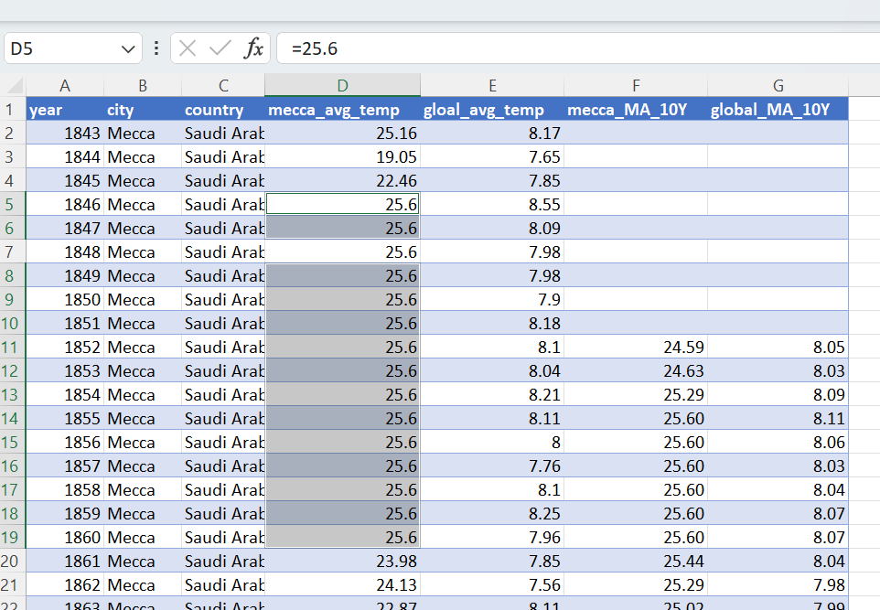

Figure 2. Fill the missing values

# Calculating the moving average

I decide to make Moving Average based on 10 years, so I calculate it as in figure using Average() function to Mecca temperature as well as the global temperature data, then I made a line chart on moving average Years.:

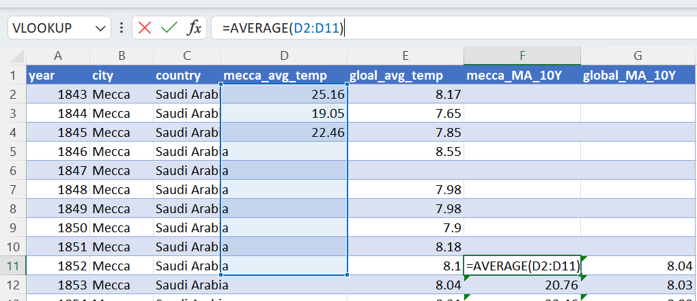

Figure 3. Moving Average calculation

# key considerations when visualize the trends

* Plot years in x-axis and Temperature in y-axis
* Use 2 different colors for global and local Temperature to better visualization the deference
* Use the moving average in line plot to clearly visualize the trend

# Visualization

Figure . Mecca vs Global Temperature by moving average for 10years

Figure . Actual trend vs smoothing trend

Figure . Mecca vs Global without moving average

# Observations

* All Mecca (local) as well as global temperatures rise with increasing years
* Mecca is warmer than global temperatures
* Slow rise in temperatures in Mecca and the global
* The overall average temperature for Mecca city is 25.6C whereas Global average temperature is 8.5C from 1843 to 2013